MINOR PROJECT
REPORT
On

HOME AUTOMATION USING IOT
Submitted to department of computer science & engineering
in partial fulfillment of the requirement for the
Bachelor of Engineering 5th semester

Bachelor of Engineering
in
COMPUTER SCIENCE AND ENGINEERING

Submitted By

Rahul Chelani 0208CS203D04



DEPARTMENT OF COMPUTER SCIENCE & ENGINEERING

Gyan Ganga College of Technology
Jabalpur, Madhya Pradesh
November 2021

PREFACE

Minor Project-I is an integral part of Bachelor of Engineering and each and every student has to create the Minor Project-I in the 5th Semester while studying in Institute.

This record is concerned about our practical Minor Project-I during 5th Semester i.e. third year of Bachelor of Engineering course. We have taken our Practical Minor Project-I in HOME AUTOMATION USING IOT During this Minor Project-I, we got to learn many new things about the technology and its practical implementation. This Minor Project-I proved to be a milestone in our knowledge of present environment. Every say and every moment was an experience in itself, an experience which theoretical study can’t provide.

ACKNOWLEDGEMENT

It is my pleasure to be indebted to various people, who directly or indirectly contributed in the development of this work and who influenced my thinking , behavior and acts during the course of study.
I express my sincere gratitude to Dr. Neeraj Shukla worthy Principal for providing me an opportunity to undergo Minor Project in Online search for Hostel/PG.
I am thankful to Dr.. Ajay Lala, HOD department of Computer Science and Engineering for his support, cooperation, and motivation provided to me during the Minor Project for constant inspiration, presence and blessings.
I also extend my sincere appreciation to all the faculties of department of Computer Science and Engineering who provided his valuable suggestions and precious time in accomplishing my Minor Project-I report.
Lastly, I would like to thank the almighty and my parents for their moral support and my friends with whom I shared my day-to day experience and received lots of suggestions that my quality of work.

Rahul Chelani

DECLARATION

I , Rahul Chelani
B.E (Semester- V) of the Gyan Ganga College of Technology, Jabalpur hereby declare that the Minor Project-I Report entitled “…HOME AUTOMATION USING IOT…….” is an original work and data provided in the study is authentic to the best of my knowledge. This report has not been submitted to any other Institute for the award of any other degree.

Place: Jabalpur
Date:

This is to certify that above statement made by the candidate is correct to the best of our knowledge.

Approved by:

(Name of the Guide)
Prof. Om Singh Parihar  Project Coordinator Assitant Professor  Department of CSE  GGCT JABALPUR |  | Dr. Ajay Lala,  Hod (CSE),  Department of CSE  GGCT,JABALPUR

GYAN GANGA COLLEGE OF TECHNOLOGY
JABALPUR (MP)


Approved by AICTE New Delhi & Govt. of M.P.
(Affiliated to Rajiv Gandhi Prodyougiki Vishwavidhyalaya, Bhopal)

Certificate
This is to certify that the Minor Project-I report entitled “ Home Automation using IOT ” is submitted by Rahul Chelani for the partial fulfillment of the requirement for the 5th semester of Bachelor of Engineering in Department of Computer Science & Engineering from Rajiv Gandhi Proudyogiki Vishwavidyalaya, Bhopal (M.P).

Prof. Om Singh Parihar  Project Coordinator  Assitant Professor  Department of CSE  GGCT,JABALPUR |  | Dr. Ajay Lala,  Hod (CSE),  Department of CSE,  GGCT,JABALPUR

Index

1. INTRODUCTION
1.1 Project Aim
1.2 Project Objective
1.3 Project Scope and Limitation
1.4 Description of the Project

2. REQUIREMENT

2.1 Hardware Requirement
2.2 Software Requirement

3. Description of Hardware Required

3.1 Atmega16 Pin Diagram
3.2 Pin Description
3.3 Architecture
3.4 Specification
3.5 Application
3.6 Hc-05 (Bluetooth Module)
3.7 Bluetooth Module Circuit connection
3.8 Bluetooth interfacing with Atmega16
3.9 4-Channel Relay Module

- SOURCE CODE

5. SOFTWARE REQUIRED
5.1 SOFTWARE USED
5.2 DESIGN & IMPLEMENTATION

6. Conclusion

- INTRODUCTION

Nowadays, we have remote control for our television sets and other electronic systems,
Which have made our life real easy. Have you ever wondered about home automation
Which would give the facility of controlling tube lights fans and other electrical
appliances at home using a remote control ? Off-course, Yes! But, are the available
options cost-effective? If the answer & No, we have found a solution to it, We have come up with a new system called Atmega16 based home automation using Bluetooth .
This system is super-cost effective and can give the user, the ability to control any electronic device without even spending for a remote control. This project helps the user to control all the electronic devices using his/her smartphone. Time is a very valuable thing.
Everybody wants to save time as much as they can, New technologies are being
introduced to save our tine. To save people's time we are introducing Home Automation
system using Bluetooth With the help of this system you can control your home
appliances from your mobile phone. You can turn on off your home appliances within the range of Bluetooth .

1.1 Project Aim
‘The aim of the project is to design and construct a home automation system that will
remotely switch on or off any household appliances connected to it, using a
Micro controller, voice dial on phone, or Bluetooth based android application

1.2 Project Objective
‘The objective of this project & to implement a low cost, reliable and scalable home
‘automation system that can be used to remotely switch on or off any household appliance,
wing a micro controller to achieve hardware simplicity, low cost short messaging service
for feedback and voice dial from any phone to toggle the switch state

1.3 Project scope and limitation
‘This project work is complete on its own in remotely and automatically switching on or ‘off of an electrical appliance not limited to household appliances and sends a feedback message indicating the new present state of the appliance.

1.4 Description of the Project
This project is one of the important Atmega16 Projects. Atmega16 based home automation using Bluetooth project helps the user to control any electronics device using Device Control app on their Android Smartphone. The android app sends commands to the
Micro controller — Atmega16 , through wireless communication, namely, Bluetooth, The Atmega16 is connected to the main PCB which has FOUR relays as shown in the block diagram.
‘These relays can be connected to different electronic devices. As per the block diagram,
Device 1 ~ Buzzer, Device 2- Fan, Device 3 ~ Lights. When the user presses on the ‘On’ button displayed on the app for the device 1, the Buzzer & switched on This Buzzer can be switched off, by pressing the same button again Similarly ,when the user presses on the ‘On’ button displayed on the app for the device 2, the fan & switched on. The fan can be switched off by pressing the same button again, This project of home automation.
when Bluetooth and Atmega16 can be used for controlling any AC or DC devices. In the demonstration, we have used DC Fan and DC Bub. To drive this DC Fan and Light, a 9V battery i connected.

Chapter-2

2.1 Hardware Requirement
‘The It of components mentioned here are specifically for controlling 4 different loads,

+ ATmega16 micro controller

+ HC—05 Bluetooth Module

+ 4-channel relay module

+ Connecting wires

* 9V Power supply

+ Smartphone or tablet (Bluetooth enabled)

2.2 Software Requirement

+ Atmel studio

+ Proteus Professional

+Hc-05 Bluetooth terminal (android application)

Chapter-3
Description of Hardware Required

3.1 ATmega16 Pin Diagram & Description

ATmega16 is an 8-bit high performance micro controller from the Atmel’s Mega AVR family. Atmega16 is a 40 pin micro controller based on enhanced RISC (Reduced Instruction Set Computing) architecture with 131 powerful instructions. It has a 16 KB programmable flash memory, static RAM of 1 KB and EEPROM of 512 Bytes. The endurance cycle of flash memory and EEPROM is 10,000 and 100,000, respectively. Most of the instructions execute in one machine cycle. It can work on a maximum frequency of 16MHz. ATmega16 pin diagram should clarify things a bit.

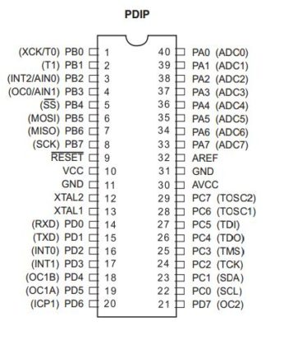
There are 32 I/O (input/output) lines which are divided into four 8-bit ports designated as PA, PB, PC and PD. ATmega16 has various in-built peripherals like USART, ADC, Analog Comparator, SPI, JTAG etc. Each I/O pin has an alternative task related to in-built peripherals. The following table shows the pin description of ATmega16.
3.2 Detailed description of the ATmega16 pin diagram:

Vcc: Digital supply voltage

GND: Ground

Port A (PA7…PA0)
Port A serves as the analog inputs to the A/D Converter. Port A also serves as an 8-bit bi-directional I/O port, if the A/D Converter is not used. Port pins can provide internal pull-up resistors (selected for each bit). The Port A output buffers have symmetrical drive characteristics with both high sink and source capability. When pins PA0 to PA7 are used as inputs and are externally pulled low, they will source current if the internal pull-up resistors are activated. The Port A pins are tri-stated when a reset condition becomes active, even if the clock is not running.

Port B (PB7…PB0)
Port B is an 8-bit bi-directional I/O port with internal pull-up resistors (selected for each bit). The Port B output buffers have symmetrical drive characteristics with both high sink and source capability. As inputs, Port B pins that are externally pulled low will source current if the pull-up resistors are activated. The Port B pins are tri-stated when a reset condition becomes active, even if the clock is not running.

Port C (PC7…PC0)
Port C is an 8-bit bi-directional I/O port with internal pull-up resistors (selected for each bit). The Port C output buffers have symmetrical drive characteristics with both high sink and source capability. As inputs, Port C pins that are externally pulled low will source current if the pull-up resistors are activated. The Port C pins are tri-stated when a reset condition becomes active, even if the clock is not running. If the JTAG interface is enabled, the pull-up resistors on pins PC5(TDI), PC3(TMS) and PC2(TCK) will be activated even if a reset occurs.

Port D (PD7…PD0)
Port D is an 8-bit bi-directional I/O port with internal pull-up resistors (selected for each bit). The Port D output buffers have symmetrical drive characteristics with both high sink and source capability. As inputs, Port D pins that are externally pulled low will source current if the pull-up resistors are activated. The Port D pins are tri-stated when a reset condition becomes active, even if the clock is not running.

RESET
Reset Input. A low level on this pin for longer than the minimum pulse length will generate a reset, even if the clock is not running. The minimum pulse length is given in Table 15 on page 38. Shorter pulses are not guaranteed to generate a reset.

XTAL1: Input to the inverting Oscillator amplifier and input to the internal clock operating circuit.

XTAL2: Output from the inverting Oscillator amplifier.

AVcc: AVcc is the supply voltage pin for Port A and the A/D Converter. It should be externally connected to Vcc, even if the ADC is not used. If the ADC is used, it should be connected to VCC through a low-pass filter.

Aref: Aref is the analog reference pin for the A/D Converter.

3.3 Architecture of Atmega16

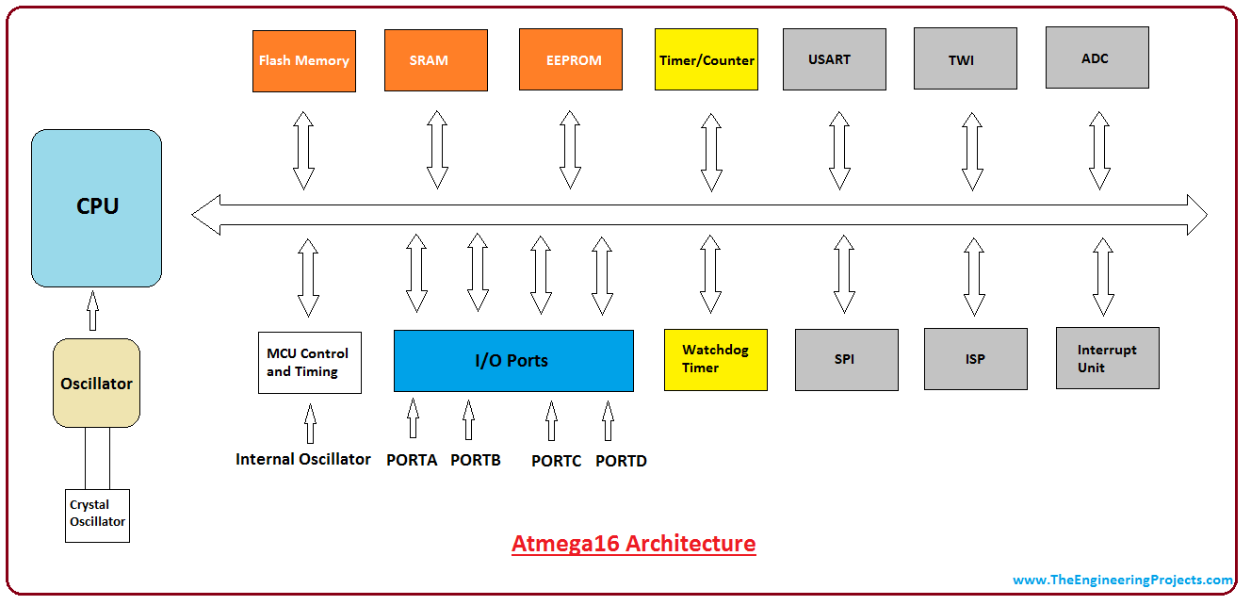

- CPU : CPU is like a brain of the controller which helps in executing a number of instructions. It can handle interrupts, perform calculations and control peripherals with the help of registers. Atmega16 comes with two buses called instruction bus and data bus.
The CPU reads the instructions in the instruction bus while data bus is used to read or write the corresponding data. The CPU mainly consists of the program counter, general purpose registers, stack pointer, instruction register and an instruction decoder.

2.Rom :The controller program is stored in ROM, also known as non-volatile programmable flash memory. The flash memory comes with a resolution of at least 10,000 write/erase cycles. Flash memory is mainly divided into two parts known as Application flash section and booth flash section.
Program of the controller is stored in the applications flash section. While booth flash section is optimized to work directly when the controller is powered up.
3.Ram :The SRAM (static random access memory) is used for storing information temporarily and comes with 8-bit registers. This is just like a regular computer RAM which is used to supply data through the runtime.
4.EEPROM :The EEPROM (Electronically Erasable Read Only Memory) is non-volatile memory used as a long time storage. It has no involvement in executing the main program. It is used for storing the configuration of the system and device parameters which continues to work in the reset of the application processor.
EEPROM comes with a limited write cycle up to 100,000 while read cycles are unlimited. While using EEPROM, write minimum instructions as per requirement, so you can get benefit from this memory for a longer time.
5.Interrupt :The interrupt is used for an emergency which puts the main function on hold and executes the necessary instructions at that time. Once the interrupt is called and executed the code switches back to the main program.
6.Analog and Digital I/O Modules :Digital I/O modules are used to set a digital communication between the controller and external devices. While analog I/O modules are used for transferring analog information. Analog comparators and ADC fall under the category of analog I/O modules.
7. Timer/Counter :Timers are used for calculating the internal signal within the controller. Atmega16 comes with two 8-bit timers and one 16-bit timer. All these timers work as a counter when they are optimized for external signals.
8.Watchdog Timer :The watchdog timer is a remarkable addition in this controller which is used to generate the interrupt and reset the timer. It comes with 128kHz distinct CLK source.
9. Serial Communication :Atmega16 comes with USART and SPI units that are used for developing serial communication with the external devices.

3.4 Specifications

‘The Atmel 8-bi AVR RISC-based micro controller combines 32 KB ISP flash memory ‘with read-while-write capabilities, 1 BEEPROM, 2 KB SRAM, 23 general purpose 10 lines, 32. general purpose working registers, thee flexible timer/counters with compare modes, internal and external interrupts, serial programmable USART, a byte-oriented 2- ‘wire serial interface, SPI serial port, 6-channel 10-bit A/D converter (8-chamek in TQFP
and QFN/MLF packages), programmable watchdog timer with internal oscillator, and
five software selectable power saving modes. The device operates between 1.8-5.5 volts.
‘The device achieves throughput approaching 1 MIPS per MHz’.

3.5 Applications

‘As of 2013 the ATmega316 is commonly used in many projects and autonomous systems

where a simply , low-powered, low-cost micro controller is needed [citation needed}

Perhaps the most common implementation of the chip & on the popular Atmel studio

development platform, namely the Atmega16 .

3.6 HC-05 Bluetooth Module

HC-05 module is an easy to we Bluetooth SPP (Serial Port Protocol) module, designed
for transparent wireless serial connection setup. Serial port Bluetooth module is filly
qualified bluetooth V20+EDR (Enhanced Data Rate) 3Mbps Modulation with complete 24GHz radio transceiver and baseband. It uses CSR Bluecore 04-Extenal single chip.
Bluetooth system with CMOS technology and with AFH (Adaptive Frequency Hopping Feature). It has the footprint as small as 12.7mmn27mm. Hope it will simplify your
overall design development cycle HC - 05.

‘The HC-05 is a very cool module which can add two-way (full-Duplex) wireless
functionally to your projects. You can use this module to communicate between two
Micro controller like atmega16 or communicate with any device with Bluetooth
functionality like a Phone or Laptop. There are many android applications that are already available which makes this process a lot easier. The module communicates with the help of USART at 9600 haul rate hence it is easy to interface with any micro controller that supports USART.
We can also configure the default values of the module by using the
Command mode. So if you looking for a Wireless module that could transfer data from your computer or mobile phone to micro controller or vice versa then this module might be the right choice for you. However do mot expect this module to transfer multimedia Iike photos or songs: you might have to look into the CSR8645 module for that

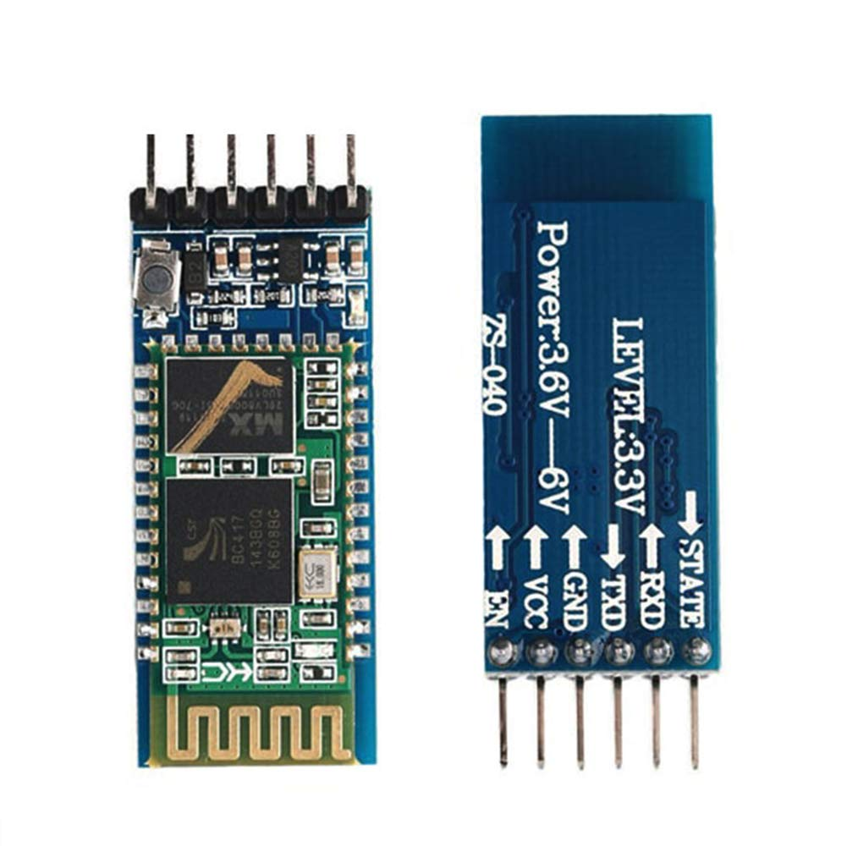

3.3.1 Use the HC-05 Bluetooth module

‘The HC-0S has two operating modes, one & the Data mode in which i can send and
receive data from other Bluetooth devices and the other & the AT Command mode where the default device settings can be changed, We can operate the device in either of these ‘two modes by using the key pin as explained in the pin description

It is very easy to pair the HC-05 module with micro controllers because it operates using the Serial Port Protocol (SPP). Simply power the module with +5V and connect the Rx pin of the module to the TX of MCU and ‘TX pin of module to Rx of MCU .

3.7 HC-05 Bluetooth Module Circuit Connections

During power up the key pin can be grounded to enter into Command mode, if left free it will by default enter into the data mode. As soon as the module is powered you should be able to discover the bluetooth device as “HC-05" then connect with it using the default password 1234 and start communicating with it,
3.8 HC-05 Bluetooth Module Interfacing with atmega16

HC.05 is a Bluetooth device used for wireless communication with Bluetooth enabled devices (like smartphone). It communicates with micro controllers using serial communication (USART). Default settings of HC-05 Bluetooth module can be changed using certain AT commands. As HC-05 Bluetooth module has 3.3 V level for RX/TX and Micro controller can detect 3.3 V level, so, there & no need to shit TX voltage level of
HC-05 module, But we need to shit the transmit voltage level from micro controller to
RX of HC - 05 module.

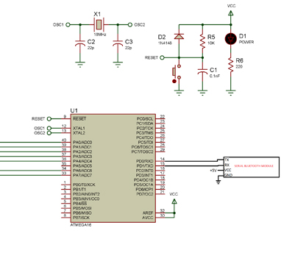

3.9 channel relay module

‘This is a 5V 4-channel relay interface board, and each channel needs a 15-20mA driver current. It can be used to control various appliances and equipment with large current. It is equiped with high-current relays that work under AC2SOV 10A or DC30V 10A. It has standard interface that can be controlled directly by micro controller
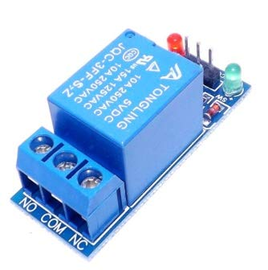

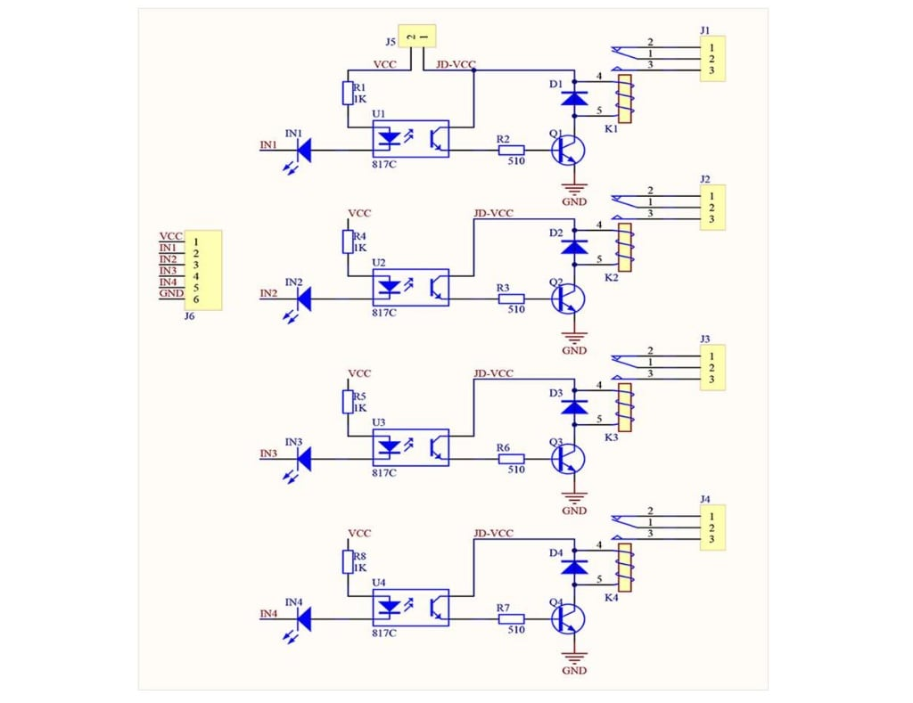

Principle

From the picture below, you can see that when the signal port & at low level the signal light will light up and the optocoupler 7817e (it transforms electrical signal by light and can isolate input and output electrical signal) will conduct, and then the transistor will conduct, the relay coil will be electrified, and the normally open contact of the relay will be closed, When the signal port & at high level, the normally closed contact of the relay will be closed. So you can connect and disconnect the load by controlling the level of the control signal port.

Features of 5-Pin 5V Relay
- Trigger Voltage (Voltage across coil) : 5V DC
- Trigger Current (Nominal current) : 70mA
- Maximum AC load current: 10A @ 250/125V AC
- Maximum DC load current: 10A @ 30/28V DC
- Compact 5-pin configuration with plastic moulding
- Operating time: 10msec Release time: 5msec
- Maximum switching: 300 operating/minute (mechanically)

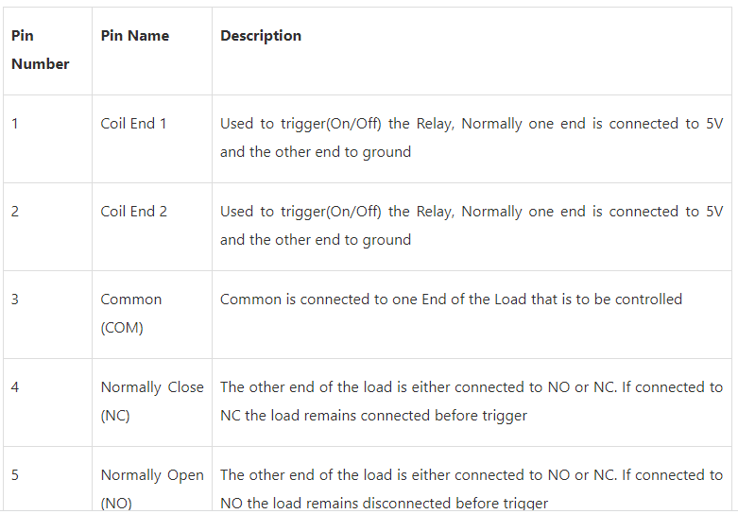

Chapter-4
Source Code
#define F_CPU 8000000ul
#include <avr/io.h>
#include <util/delay.h>

void uart_init()
{
UCSRB|=(1<<RXEN)|(1<<TXEN); // enable disable
UCSRC |=(1<<URSEL) /*To select Usart*/|(1<<UCSZ0)|(1<<UCSZ1);//z0-z1-z2(char size select) if 2 bit high krte hai toa 8 bit size ka data select ho jata hai
UBRRL=51; //DECIMAL FORMULA FREQUENCY 8 MHZ FOR BAUD RATE 9600
}

void uart_tx(char d)
{
//debouncing (hold the code)
while(!(UCSRA &(1<<UDRE))); //0 !=1 usart data register is empty
UDR=d; // udr is register whose value is d
}

char uart_rx()
{
//debouncing
while(!(UCSRA &(1<<RXC))); //0 !=1 usart data register is empty
return(UDR); // ereturn udr (usart data register)
}

int main(void)
{
char array[]="ahul";
DDRA=0xff;
DDRC=0xff;

uart_init(); //calling function of initializing uart
uart_tx('R'); //Uart transmit

for (char i=0;i<=3;i++)
{
uart_tx(array[i]);
}

for (int i=0; i<=7; i++)
{
PORTC=(1<<i);
_delay_ms(1000);
}

while(1)
{
char a=uart_rx();
if (a=='a')
{
PORTA|=(1<<PA0);
}

else if (a=='b')
{
PORTA|=(1<<PA1);
}

else if (a=='c')
{
PORTA|=(1<<PA2);
}

else if (a=='d')
{
PORTA|=(1<<PA3);
}

else if (a=='1')
{
PORTA&=~(1<<PA0);
}

else if (a=='2')
{
PORTA&=~(1<<PA1);
}

else if (a=='3')
{
PORTA&=~(1<<PA2);
}

else if (a=='4')
{
PORTA&=~(1<<PA3);
}
}
}

- SOFTWARE REQUIRED

- Atmel studio :Atmel Studio is a integrated development platform for developing and debugging all AVR and SAM micro controller applications. The Atmel Studio IDP gives you an environment to write, build, and debug your applications written in C/C++ or assembly code.

- Proteus 8 : Proteus 8 Professional is a software which can be used to draw schematics, PCB layout, code and even simulate the schematic. It is developed by Lab center Electronic Ltd.

- 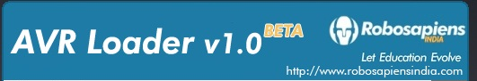
AVR LOADER: This software is GUI for AVR Dude. AVR Dude is an open source utility to download, upload and manipulate the ROM and EEPROM contents of AVR microcontrollers using the in-system programming technique (ISP).

DESIGN & IMPLEMENTATION

A low cost and efficient smart home system i presented in our design. This system has two main module: the hardware interface module and the software communication module , At the heart of this system & the Atmega16 micro controller which is also capable of functioning as a micro web server and the interface for all the hardware modules. All communication and controls in this system pass through the micro controller.

Technical Specification for this project

1) A smartphone or an Android mobile which should have the android app installed in it,
2) Bluetooth receiver module ~ Our project will be connected to the smartphone using Bluetooth technology.

3) Controller or the main processing cut- In this project, Atmega16 is the main
controlling / processing unit.

4) LCD Display ~ The Liquid Crystal Display & optional but shows important messages like device status once command is received from Bluetooth

'5) Relays to control devices ~We have used 12 volt Single push single throw relays.

- Output devices ~ For the demo purpose, we connected a DC devices to a relay (12 volt DC bub). You can connect any AC/DC devices to the remaining 3 relays.

DESIGN

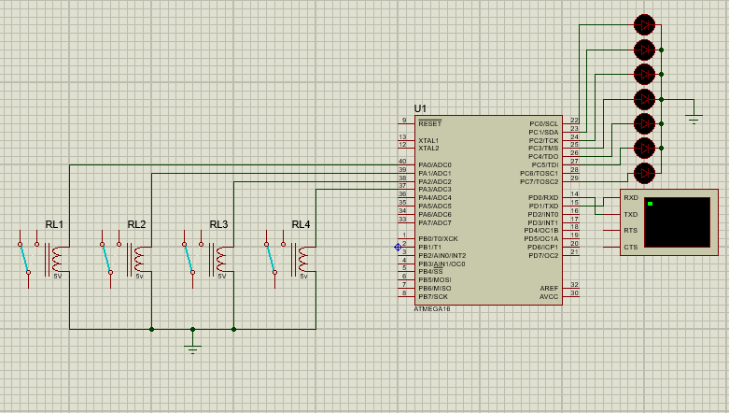
6. Conclusion

‘The home automation system has been experimentally proven to work satisfactorly by connecting simple appliances to it and the appliances were successfully controlled from a wireless mobile device. We learned many skills such as code the micro controller soldering in 0 pcb, wiring the circuit and their tools that we use for this project and was able to work together as a team during this project.
The Bluetooth connection was successfully tested on a different mobile
phones from different manifacturers , thus proving its portabliy and wide compatibility.
‘Thus a low-cost home automation system was successfully designed, implemented and used…!

